7-Day Organic Meal Plan for Athletes
Key Features:
- Packed with nutrients for performance, recovery, and muscle repair
- Includes healthy fats, complex carbs, and high-quality proteins
- Organic, fresh ingredients for optimal energy
- Delicious, creative, and easy-to-make recipes

Day 1
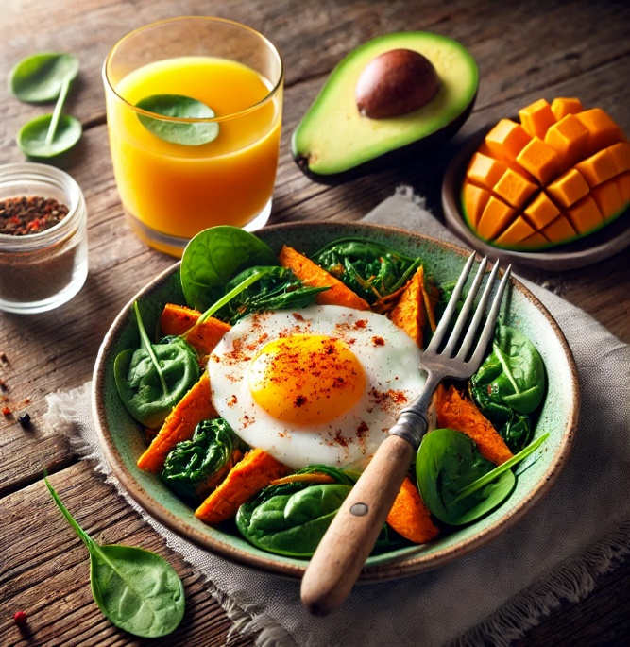
Breakfast: Organic Sweet Potato & Spinach Egg Scramble
- Ingredients: Organic eggs (3), diced sweet potato (1 small), spinach (1 cup), avocado (½), olive oil, spices (paprika, salt, pepper).
- Instructions: Sauté sweet potato in olive oil until tender. Add spinach and eggs, scramble until cooked. Serve with sliced avocado.
Snack: Homemade Trail Mix
- Ingredients: Raw almonds, cashews, dried cherries, dark chocolate chips, and sunflower seeds.
Lunch: Grilled Lemon Herb Chicken with Quinoa Salad
- Ingredients: Organic chicken breast, quinoa, cucumber, cherry tomatoes, parsley, lemon, olive oil.
- Instructions: Grill chicken marinated in lemon, garlic, and herbs. Toss quinoa with chopped veggies and a drizzle of olive oil and lemon juice.
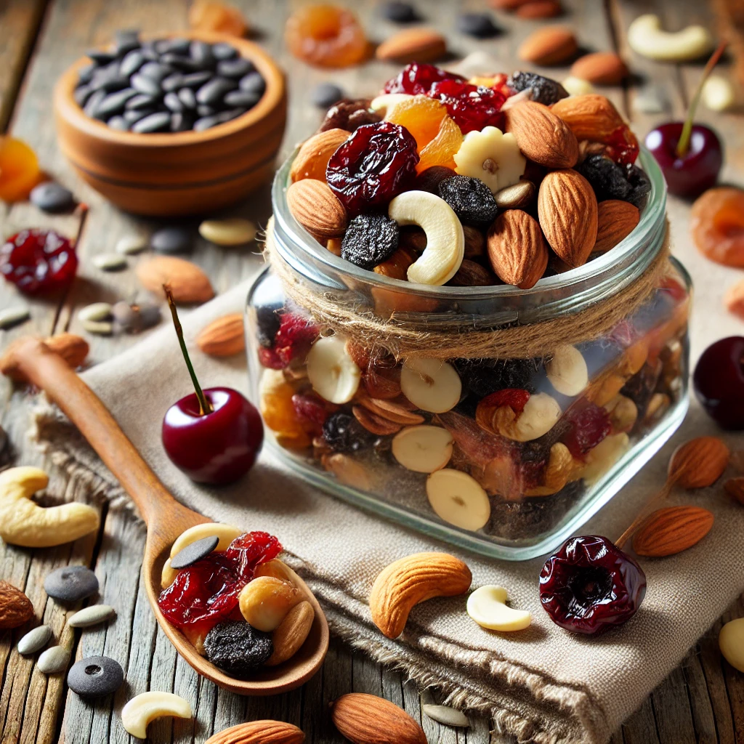
Snack: Greek Yogurt with Organic Honey and Berries
- Ingredients: Full-fat Greek yogurt, fresh organic blueberries, strawberries, and a drizzle of honey.
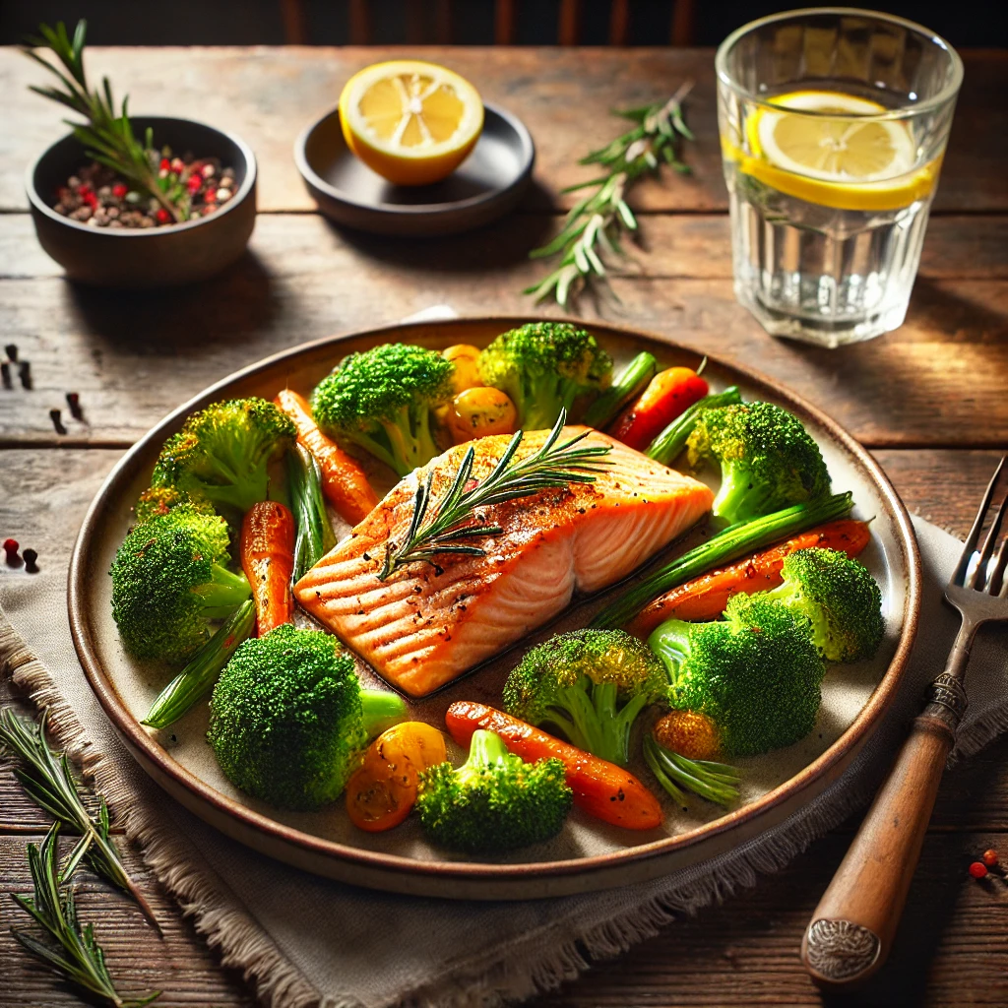

Dinner: Baked Salmon with Roasted Veggies
- Ingredients: Organic salmon fillet, broccoli, carrots, sweet peppers, olive oil, garlic, rosemary.
- Instructions: Bake salmon at 375°F for 15 minutes. Roast veggies with olive oil and garlic on a baking sheet alongside.

Day 2
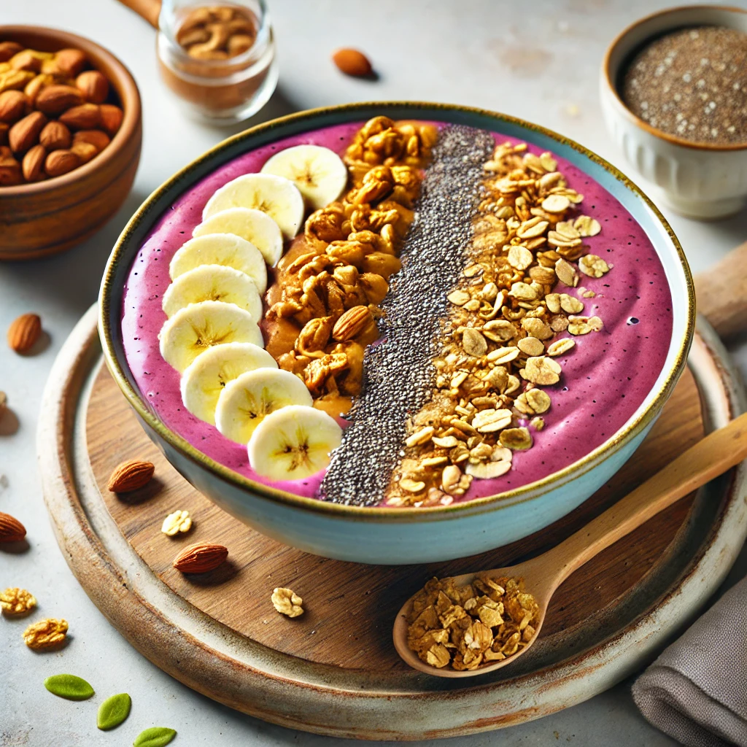
Breakfast: Banana Almond Smoothie Bowl
- Ingredients: Organic banana, almond butter, almond milk, granola, chia seeds.
- Instructions: Blend banana, almond butter, and almond milk. Top with granola, chia seeds, and sliced banana.
Snack: Sliced Veggies with Hummus
- Ingredients: Carrots, celery, cucumber, organic hummus.

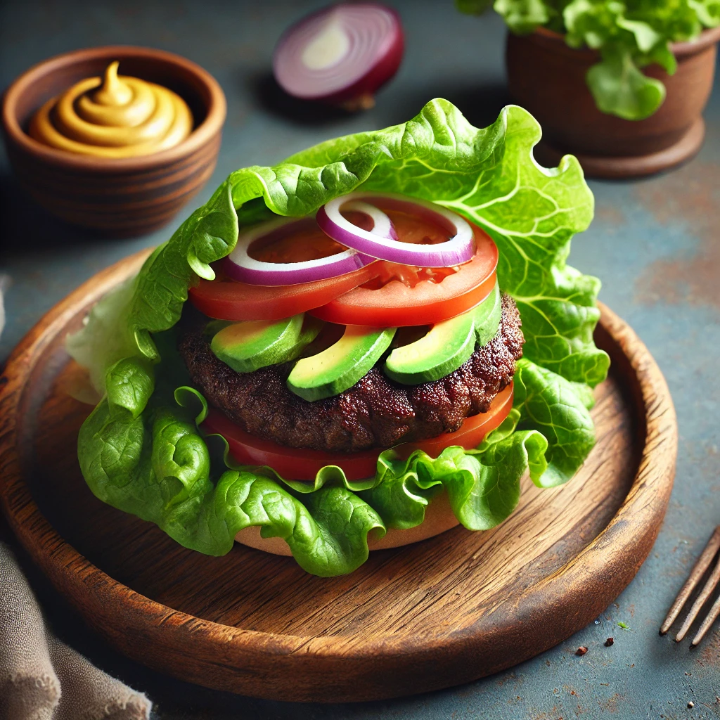
Lunch: Grass-Fed Beef Burger Lettuce Wraps
- Ingredients: Grass-fed beef patty, large lettuce leaves, sliced tomato, onion, avocado, organic mustard.
- Instructions: Grill beef patty. Assemble burger in lettuce wraps with toppings.

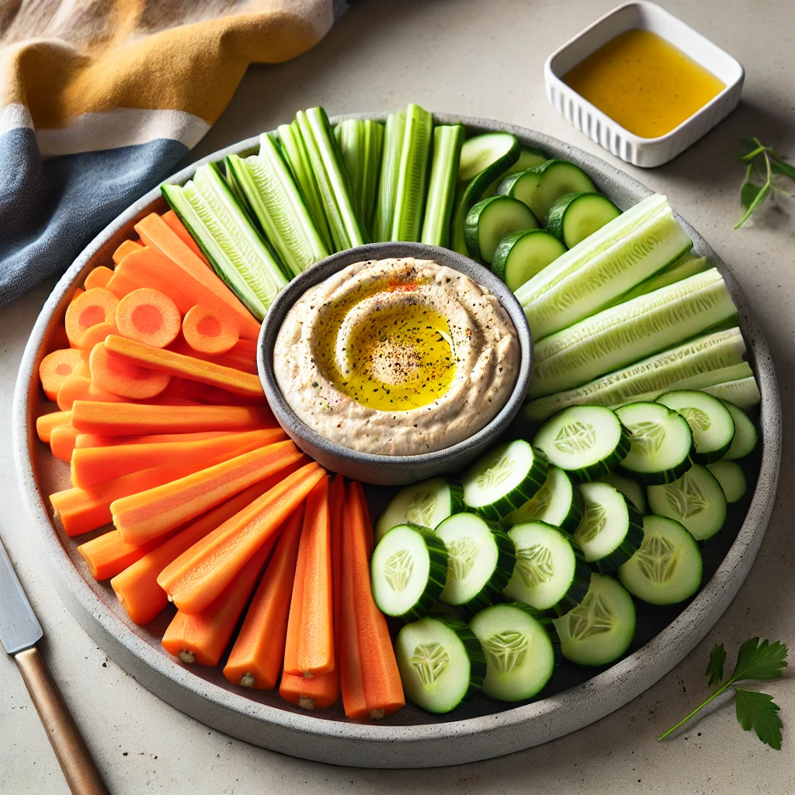
Snack: Apple with Almond Butter
- Ingredients: Organic apple slices, almond butter.
Dinner: Organic Turkey Stir-Fry with Brown Rice
- Ingredients: Ground turkey, bell peppers, zucchini, snap peas, tamari (soy sauce alternative), sesame oil.
- Instructions: Stir-fry turkey and veggies in sesame oil with tamari. Serve over brown rice.

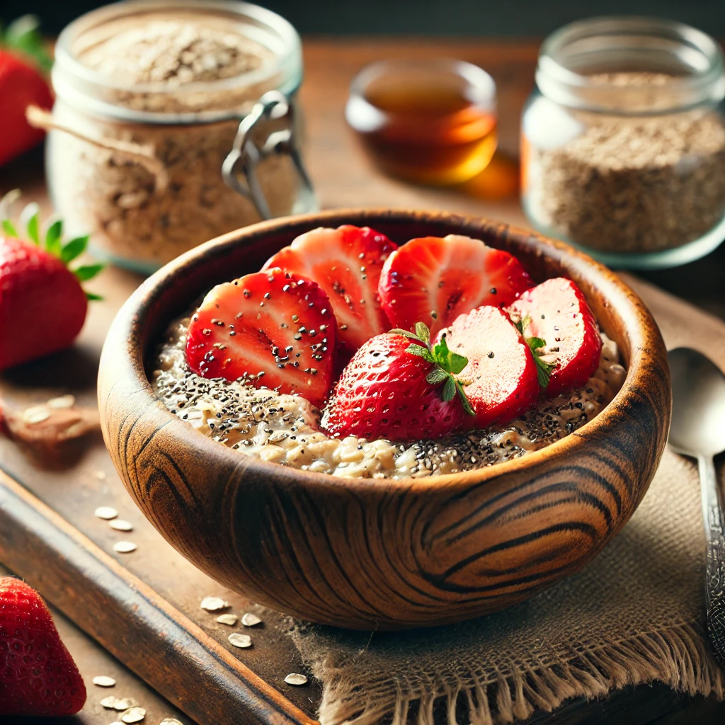
Day 3
Breakfast: Overnight Oats with Fresh Fruit
- Ingredients: Organic rolled oats, almond milk, chia seeds, sliced strawberries, maple syrup.
- Instructions: Combine oats, almond milk, and chia seeds in a jar. Refrigerate overnight. Top with fresh fruit and maple syrup in the morning.
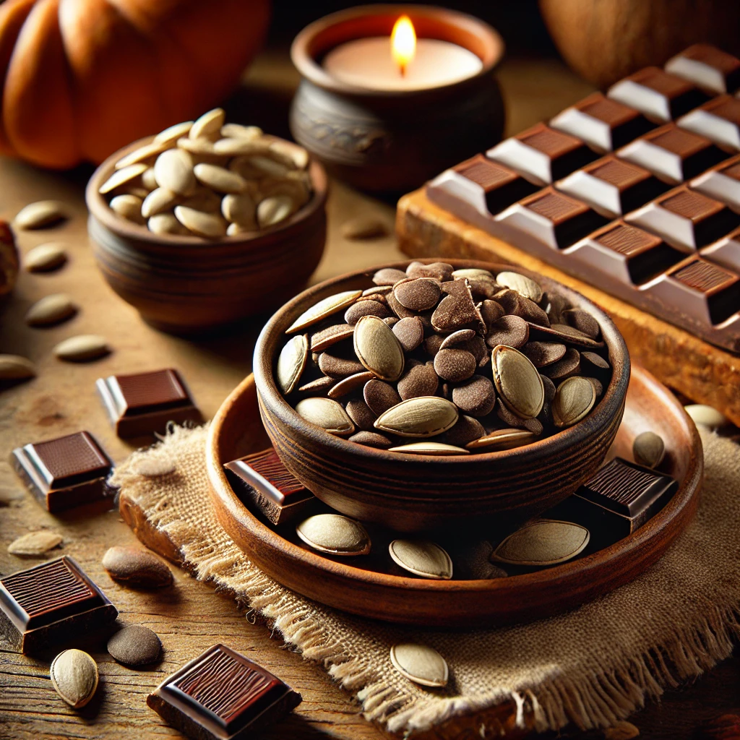
Snack: Pumpkin Seeds & Dark Chocolate Bites
- Ingredients: Handful of roasted pumpkin seeds and 70% dark chocolate pieces.
Lunch: Zesty Shrimp & Avocado Salad
- Ingredients: Organic shrimp, avocado, arugula, cherry tomatoes, lime juice, olive oil.
- Instructions: Sauté shrimp in olive oil and lime juice. Toss with arugula, tomatoes, and avocado.
Snack: Hard-Boiled Eggs with Sea Salt
- Ingredients: 2 organic hard-boiled eggs, sea salt, pepper.
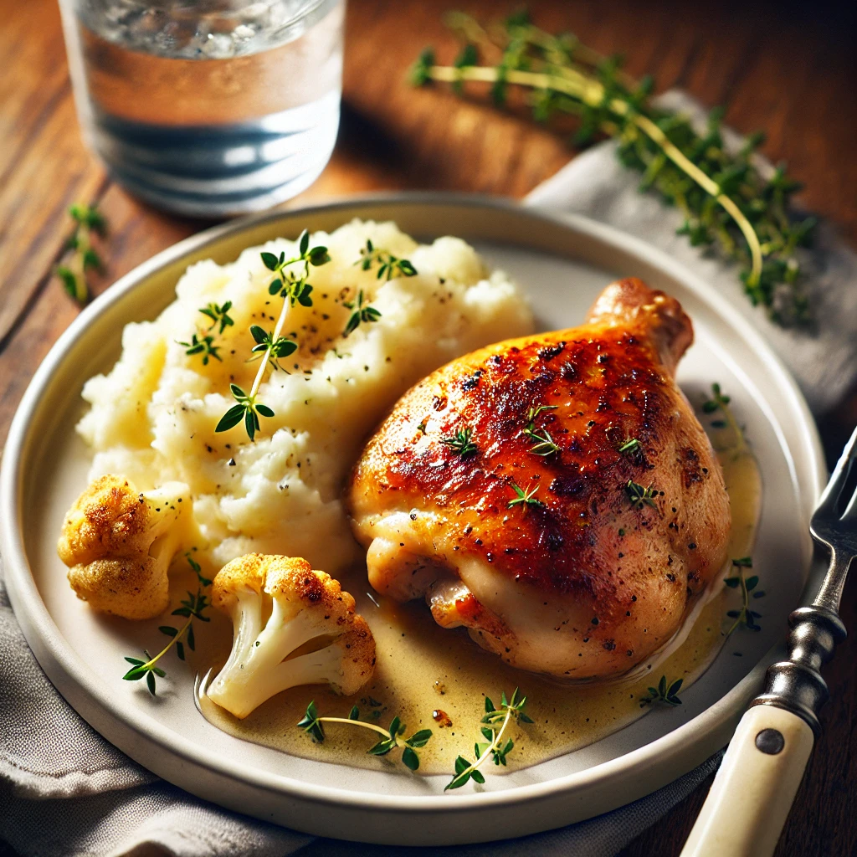

Dinner: Roasted Chicken Thighs with Mashed Cauliflower
- Ingredients: Organic chicken thighs, cauliflower, garlic, butter, fresh thyme.
- Instructions: Roast chicken thighs with garlic and thyme. Steam cauliflower and blend with butter and garlic for a creamy mash.

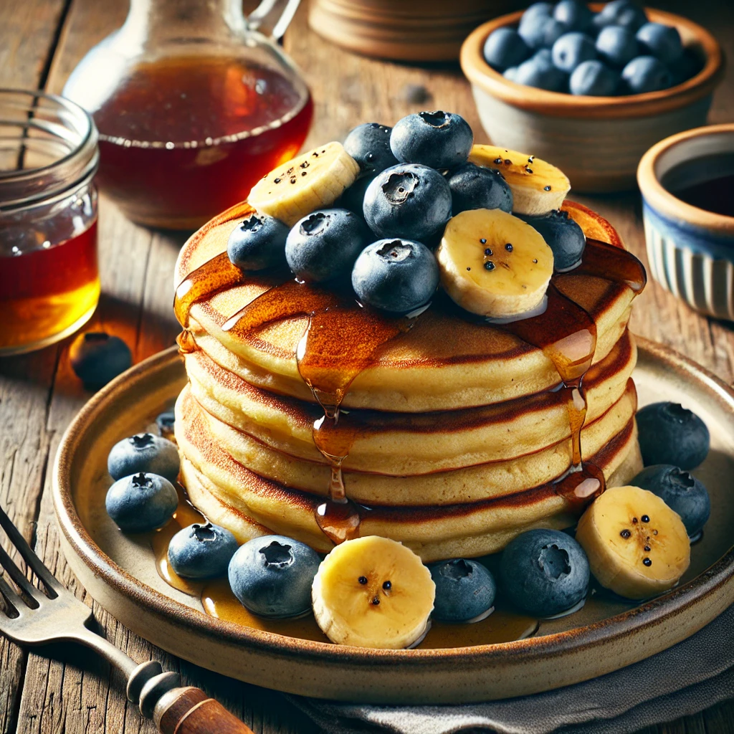
Day 4
Breakfast: Power Pancakes
- Ingredients: Organic oats, eggs, banana, almond milk, cinnamon, blueberries.
- Instructions: Blend oats, eggs, banana, and milk into batter. Cook pancakes and top with blueberries and a drizzle of maple syrup.
Snack: Smoothie
- Ingredients: Spinach, frozen mango, organic protein powder, coconut water.
Lunch: Buddha Bowl with Tahini Dressing
- Ingredients: Quinoa, roasted sweet potato, chickpeas, kale, tahini, lemon.
- Instructions: Assemble ingredients in a bowl, drizzle with tahini dressing.
Snack: Cucumber & Avocado Roll-Ups
- Ingredients: Sliced cucumber, avocado, smoked salmon.
Dinner: Grilled Grass-Fed Steak with Asparagus
- Ingredients: Grass-fed steak, asparagus, olive oil, garlic.
- Instructions: Grill steak and asparagus. Serve with garlic olive oil drizzle.

Day 5
Breakfast: Avocado Toast with Poached Egg
- Ingredients: Whole-grain toast, avocado, poached organic egg, chili flakes.
- Instructions: Spread avocado on toast, top with poached egg and chili flakes.
Snack: Roasted Chickpeas
- Ingredients: Organic chickpeas, olive oil, smoked paprika, sea salt.
- Instructions: Roast chickpeas with spices at 400°F for 20 minutes.
Lunch: Teriyaki Salmon Bowl
- Ingredients: Organic salmon, brown rice, steamed broccoli, teriyaki sauce.
- Instructions: Cook salmon in teriyaki sauce. Serve over rice and broccoli.
Snack: Peanut Butter Protein Balls
- Ingredients: Peanut butter, oats, organic protein powder, honey.
- Instructions: Mix and roll into bite-sized balls.
Dinner: Stuffed Bell Peppers
- Ingredients: Bell peppers, quinoa, ground turkey, tomato sauce, mozzarella.
- Instructions: Fill halved peppers with cooked turkey, quinoa, and sauce. Top with cheese and bake at 375°F for 20 minutes.

Day 6
Breakfast: Chia Pudding with Berries
- Ingredients: Chia seeds, almond milk, vanilla, fresh organic berries.
- Instructions: Combine chia seeds with almond milk and vanilla. Refrigerate overnight. Top with berries.
Snack: Nut Butter and Rice Cake
- Ingredients: Rice cake, almond butter, sliced banana.
Lunch: Grilled Chicken Caesar Salad (Healthy Twist)
- Ingredients: Organic chicken, kale, romaine, organic parmesan, Greek yogurt Caesar dressing.
Snack: Green Juice
- Ingredients: Kale, cucumber, celery, green apple, lemon.
Dinner: Zoodles with Pesto and Grilled Shrimp
- Ingredients: Zucchini noodles, organic pesto, shrimp, cherry tomatoes.

Day 7
Breakfast: Spinach and Mushroom Omelet
- Ingredients: Organic eggs, spinach, mushrooms, goat cheese.
- Instructions: Sauté spinach and mushrooms. Add whisked eggs and cook until set. Top with goat cheese.
Snack: Berry Parfait
- Ingredients: Greek yogurt, granola, organic mixed berries.
Lunch: Grass-Fed Beef and Veggie Stir-Fry
- Ingredients: Grass-fed beef strips, broccoli, carrots, bell peppers, tamari.
Snack: Avocado Deviled Eggs
- Ingredients: Hard-boiled eggs, avocado, lime juice.
Dinner: Roast Chicken with Sweet Potato Wedges
- Ingredients: Organic chicken, sweet potato, rosemary, olive oil.
- Instructions: Roast chicken and sweet potato wedges seasoned with rosemary and olive oil.

